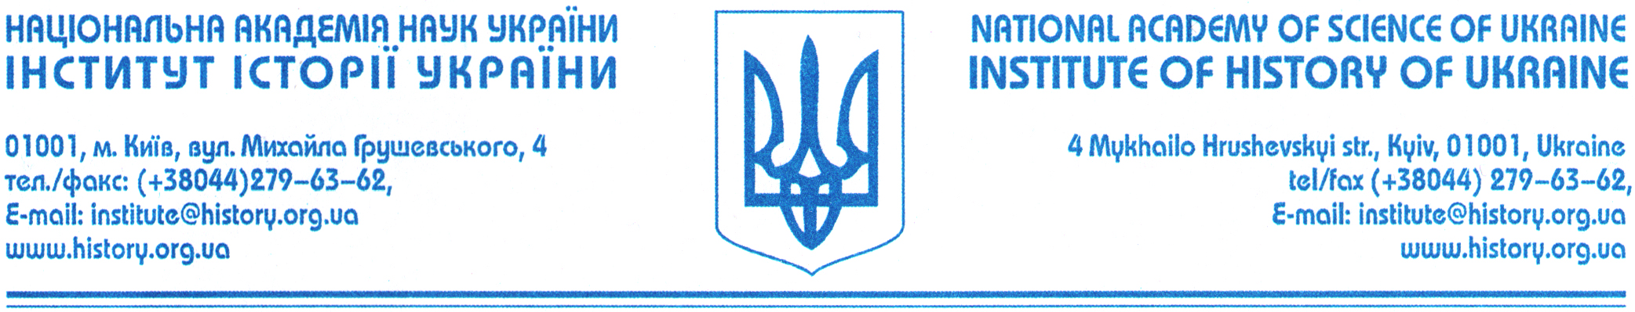

PROGRAM OF THE FIRST INTERNATIONAL RESEARCH CONFERENCE ON WEAPONOLOGY
February 16–19, 2014.
Central House of Officers of the Armed Forces of Ukraine
Hrushevski str., 30/ 1, Kyiv, Ukraine.

Feb. 15.
Arrival and meeting of the participants.

Feb. 16.
10:00–11:00. Registration of participants.
11:00. Opening Ceremony;
12:30. Coffee Break;
13:00–16:00. Plenary lectures:
Tomasz Ciesielski. «The Artillery Weapon in the Polish and Lithuanian army in the years 1717–1789».
Anna Feuerbach. «Koftgari and Other Related Methods of Decoration on Weapons».
Iryna Forostyan. «The study of general problems of the history of arms and armors. Importance and necessity of collaboration between historical museums in the current geopolitical setting».
Manouchehr Moshtagh Khorasani. «Persian manuscripts on cannon making, different types of ordnances (cannons, howitzers and mortars), rockets and fireworks».
Michael Gorelik. «The burial of the Golden Horde Circassian warrior of 13–15th cc. in Porosye».
Alexander N. Kulinsky. «Private collections of antique arms and armor in Ukraine and Poland before 1917».
Vitaly Shlaifer. «Scythes in the Weapon History Museum».
17:30. The gala banquet;

Feb. 17.
10:00–13:00. Plenary lectures:
Vladimir Berejinsky. «The main types of the Ottoman sabers».
Leonid Bobrov. «Kalmyk cavalry at the Russo-Polish War of 1654–1667: Armament and Tactics».
Nicholaj Plavinsky. «Weapons of Local Production and Imported Weapons in the Complex Weapons of the Western Lands of Rus in the 11–13th centuries: principles and criteria оf selection».
Dmitry Badaev. «Panzer Мк-V – the monument in Kharkiv».
Katharine Valentirova. «Cold steel from sunken Italian ship of the 13 c.».
Bohdan Grinchishin. «Finds of medieval swords as an important source for the study of military affairs in the Galicia-Volyn state».
Vladimir Hutsul. «Weapons and Tactics of hussar cavalry in the visual sources of the first third of the 16th c.».
Sergey Zelenko. «Spheroconical vessels from a 13th-century ship-containers or weapon?».
Vitaly Kalinichenko, Sergey Pivovarov. «Items of arms ranged from Chornivka hillfort of the first half of 13 c. (archeological research of 2012)».
Alexander Berezkin. «Experience of restoration of the iron sword hilt (10th century?)».

13:00–14:00. Dinner;
14:00–18:00. Plenary lectures:
Victor Kobets. «Archaeological researches of the river Dneper by the employees of Kiev National University in 2010-2013».
Roman Kosarev. «Hand weapons on the territory of Ukraine of 15–18 cc.»
Artem Laevsky. «Cold steel in collection of the Chernigov Historical Museum».
Oleg Malchenko. «Dutch 15th century forged cannon from Tavrida Central Museum».
Helena Popelnytska. «Swords of the second half of 13–15 cc. from the collection of the National Museum of History of Ukraine».
Helena Pohodyascha. «Pictures of arms and symbols of power in the Cossack portraits of the 17–first half of the 19 cc.».
Vladimir Prokopenko. «Saber belt hanger with a hook-clasp. Eastern Europe, Ottoman Empire 16– to early 18th century».
Eugene Sivachenko. «The use of jade in arms art of India Mughal era: historical, technical and artistic aspects (samples exhibits in the Feldman Family Museum)».
Alexander Strelchenko. «On a group of swords 14–15 centuries from South-Western and Western Rus»
Sviatoslav Tersky, Vladimir Savitsky. «A knobsticks of 10–13 cc. in Galician-Volyn lands».
Nicholas Cherkes, Vladimir Berejinsky. «Firearms of the Ottoman empire».
Helena Popelnytska. «Sword of the first third of 19 c.of a Russians’ statesman А.D. Balashov in the collection of the National museum of history of Ukraine».

Feb. 18.
11:00. Seminar on the traditional Persian martial arts conducted by Dr. M. M. Khorasani (55 Polovetska str.).
16:00. Guided tour the National Museum of History of Ukraine.

Feb. 19.
10:00. Discussion on legislation collectibles.

